**GUSignal Software**

**Instructions for the use:**

1. Before starting, review the flowchart to visualize the general functioning of the software.
2. When the application is open, click on “Input Image” button to import the image you wish to analyze. This image will be displayed in the axis 1.

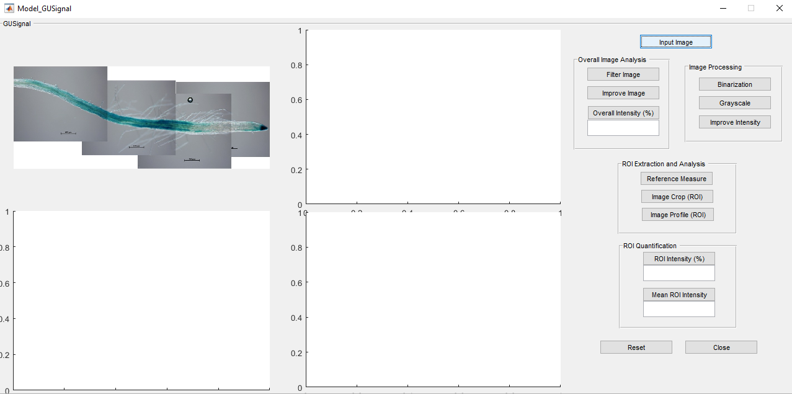

1. If you want to analyze the intensity of the overall image: Click on “Filter Image” button and then click on “Improve Image”. Finally, click on “Overall Intensity (%)” to calculate the percentage of intensity.

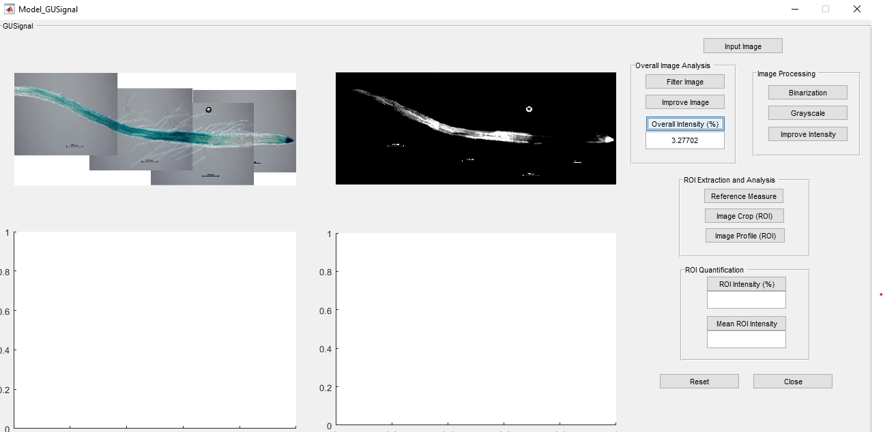

1. To analyze the intensity of the region of interest: click on “Binarization” button, then click on “Grayscale” button and after that, click on “Improve Image” button. This will allow us to visualize the image in the conditions we need to evaluate the intensity levels.

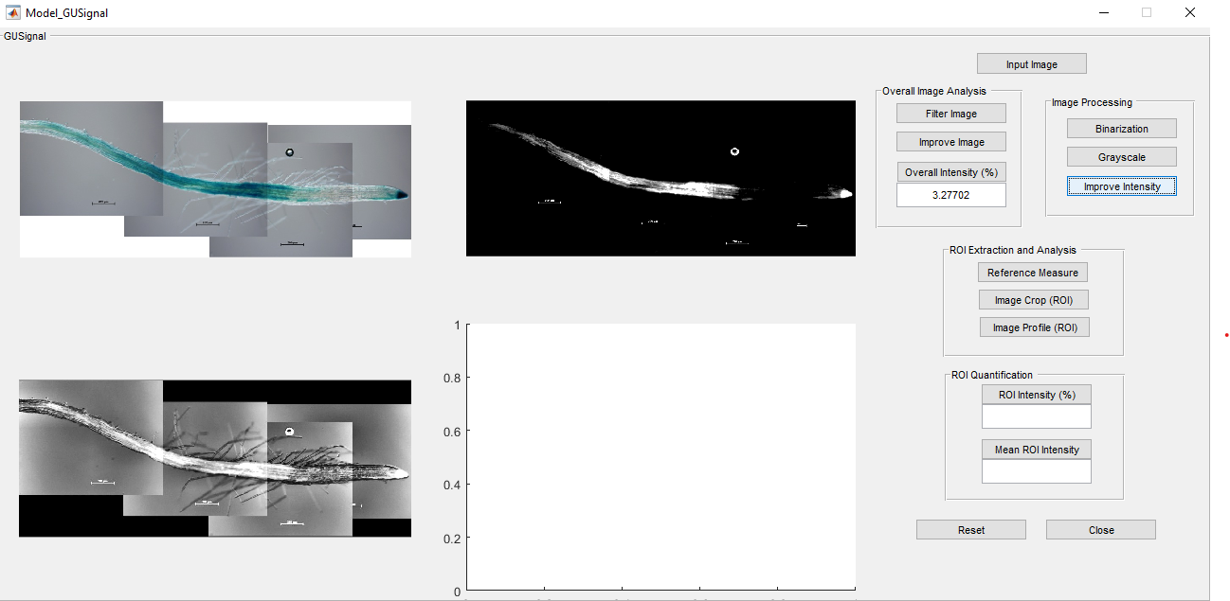

1. Then, click on “Reference Measure” button for setting a reference line in micrometers (um). Therefore, go to the image of axis 3, click once on a point of the meristematic section and then click and hold to drag the reference measurement.

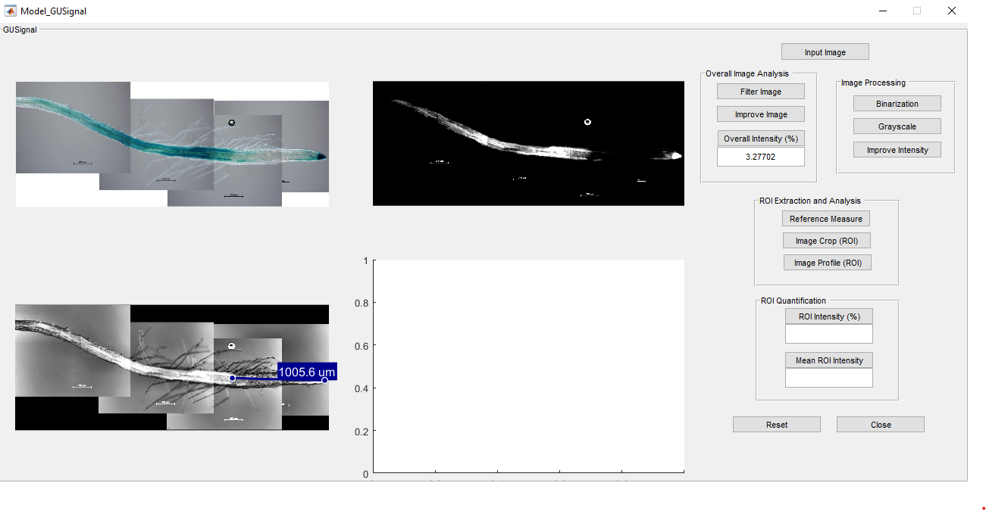

1. Then click on “Image Crop” button. Go to the image and click and hold to select our rectangular region of interest (ROI) from the reference measurement. Finally, double click in the rectangular figure and can observe the new image (ROI).

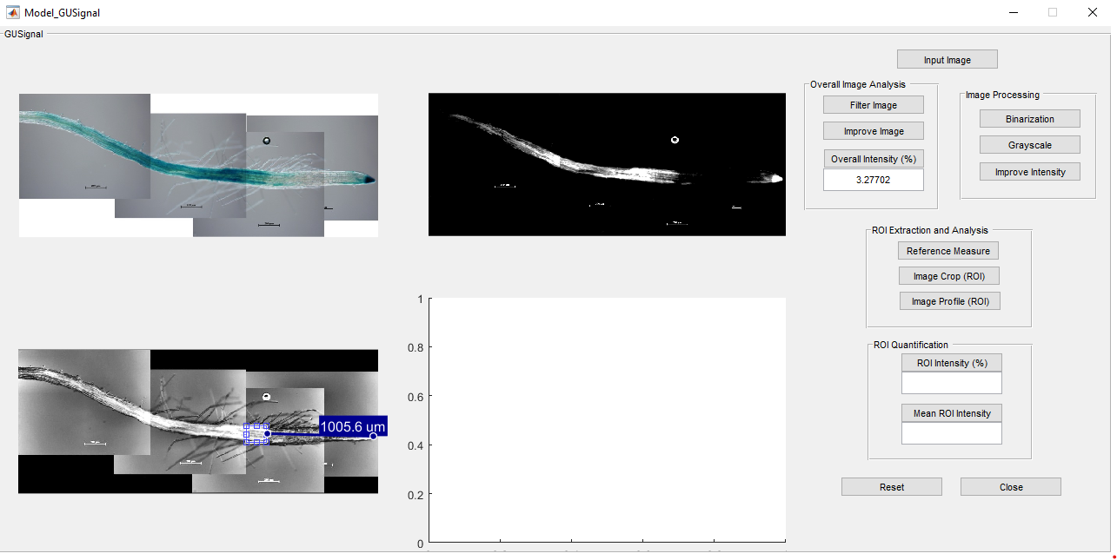

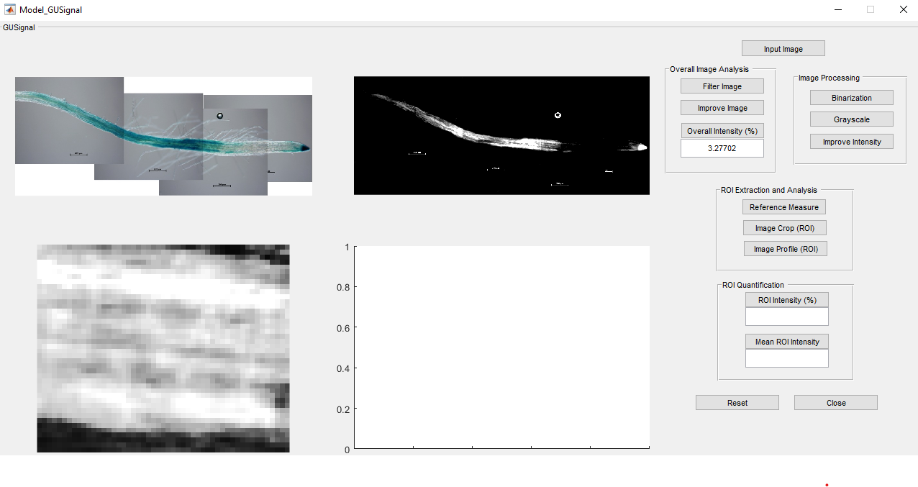

1. After that, click on “Image Profile” button and go to our ROI image to draw a segment from side to side in order to obtain our intensity profile (histrogram). Click on the starting point, drag the line to the end point of interest and click again. When the line is drawn, press enter, the intensity profile will appear on axis 4.

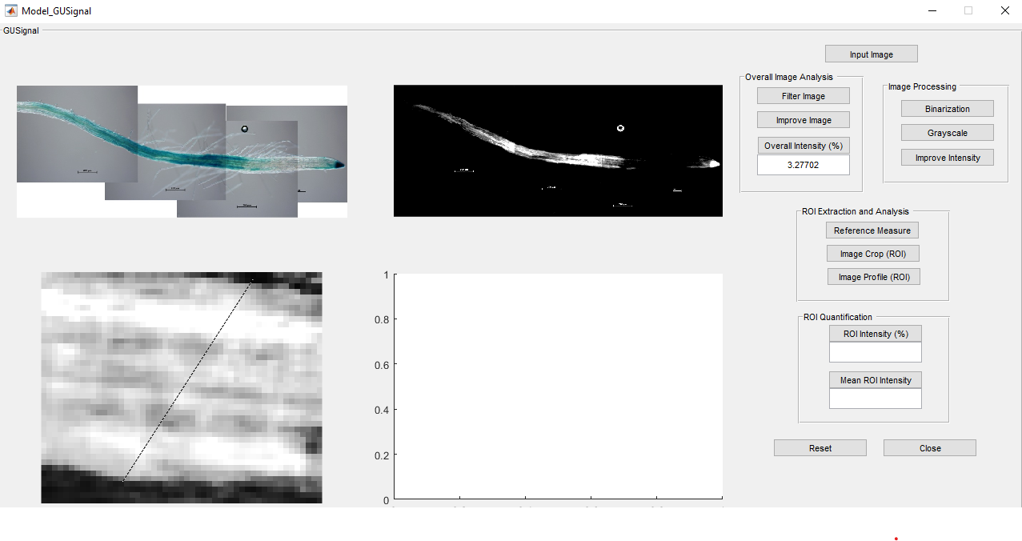

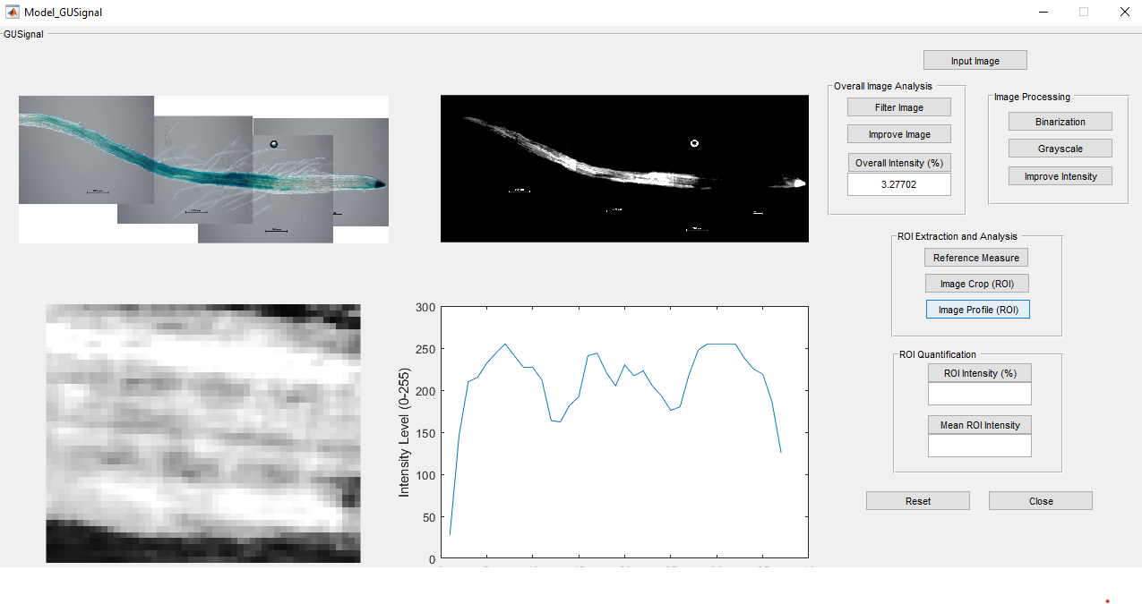

1. Finally, click on “ROI Intensity” and “Mean ROI intensity” button to quantify the intensity levels of the ROI both as a percentage and as a mean.

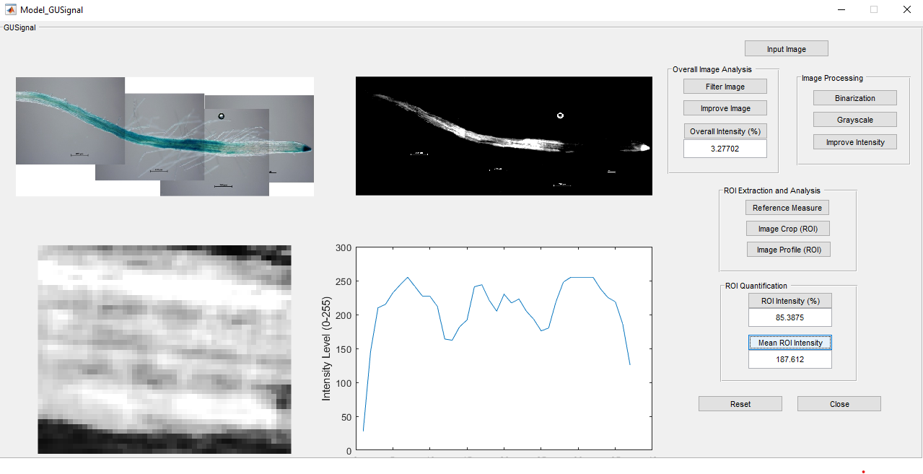

1. If you want to make a new analysis, click on “Reset” button to follow the same process again or if you want to close the App, click on “Close” button.